

EBUS633-Big Data analytics for Business Coursework

Year: 2022-2023

Assignment No: 2
Semester 2
Topic: Impact of a 2016 Presidential Election on a
publicly listed U.S. Financial companies in terms of abnormal stock returns.

Table Of Content :

Sr. No. | Title | Page No.
1) | Introduction | 3
2) | Hypothesis Development | 4
3) | Event Statement | 5
4) | Intergroup Comparison | 7
5) | Intergroup Test Result | 9
6) | Discussion | 10
7) | Appendices | 11
8) | References | 12

Introduction
“The lack of money is the root of all evil ”- Mark Twain
This report focuses on the 2016 Presidential election and the significant impact it had on the financial companies listed in the US stock market. The stock market is an essential component of a nation's financial system and a driver of economic expansion. United States holds one the biggest democratic elections every 4 years (Hashim, N. 2020). American citizens who are eligible to vote cast their ballots to elect the President of the United States in the quadrennial US presidential elections.
The results of these elections will significantly affect the political climate, course of national policy, and nature of the nation's connections with other countries. The 2016 US presidential elections significantly affected the stock prices of financial corporations listed on the US stock market. After Donald Trump was elected, there was a period of unpredictability and volatility, which caused stock values to fluctuate dramatically (Shaikh, I. 2017).
The reason why I chose to study this election and its impact is as following:
- Policy Effect
- Sentiments of Investors
- Economic Variations in the prices
- Change in regulatory environment
- Tac Policies and its impact
It had huge correlations with the financial policies announced by the Trump camp before elections and the actual impact post declaration of the results (Crandall, C.S., et. al, 2018). Here, I will be concentrate my ethics and study on the significant impact on the stock prices of the companies, how the prices were fluctuating and if the companies affected positively or negatively. It will help to understand the state and effects on the economy. For this , I shoes the companies in the Finance sector with the Standard Industrial Classification (SIC) codes from 6000 – 6799 (Fertuck, L. 1975).

Hypothesis development
Hypothesis 1:
The H1 hypothesis of the report states that there was an overall positive impact on the financial firms after the 2016 Presidential Election result. The Trump administration pushed initiatives to reduce the regulatory burdens placed on financial institutions, which may have had a positive impact on the operations, compliance costs, and overall profitability of the financial firms. President Trump made a point of stressing the importance of massive infrastructure spending during his campaign (Duan J., et. al. 2018).
The market responded favourably to the planned economic policies of the new administration, which included tax cuts, lessened regulation, and prospective infrastructure spending. These justifications list a number of elements that may have helped explain the 2016 Presidential Election result's overall favourable effect on financial firms. It is significant to remember that market dynamics can be complicated and that individual company performance can vary depending on a variety of factors other than the results of an election.

Hypothesis 2:
The Presidential Election of 2016 had more positive impact on the stocks return of the domestic companies than the international companies. I have performed the hypothesis using the intergroup comparison. Because it enables insightful comparisons and insights between various groups or categories, intergroup comparison is a suitable method for analysing and comprehending the impact of the 2016 presidential election. It gives an interesting quantitative dimension that is pertinent. The relative impact on the stock returns of domestic and foreign companies can also be influenced by factors such as trade policies, economic policies, infrastructure spending, currency manipulation, market sentiment, sector-specific dynamics, global economic conditions, and company-specific traits.

Hypothesis 3:
The Presidential Election of 2016 had more positive impact on the stocks return of the companies having high R&D intensity than low R&D intensity. Numerous variables affect how the election affects stock returns, and the association between R&D intensity and stock returns can change depending on the sector, level of competition, and performance of the companies involved. For a thorough understanding of the relationship between the election and stock returns for companies with various R&D intensities, careful empirical study and consideration of additional factors are essential.

Event Statement
I conducted the event study considering the test H1. The provided results are from a market model analysis, using an estimation window of 100 days and an event window of 21 days, to assess the impact of the US presidential elections in November 2016 on the stock prices of finance companies listed in the US stock market.
- The Estimation Window can be defined as the window, which is often referred to as the estimation period, is a particular time frame used in event studies to calculate the anticipated returns of a stock or portfolio.
- The event window can be defined as an event studies, the event window—a predetermined time frame immediately preceding an event of interest—is looked at to determine how the event would affect a particular variable, such stock prices.
- The analysis focuses on the Average Abnormal Return (AAR) and Cumulative Abnormal Return (CAR) during the event window.
Looking at the results, it appears that the impact of the presidential elections on the stock prices of finance companies was mixed. The analysis shows varying AAR values across different event times. In the early event times, such as -10 and -9 days, the AAR values are relatively small and statistically insignificant. On some days like ( -10, -8,-6,1 ,4 ,9) which has p-values< 0.05 which shows the significant impact of the election on the stock prices. With p-values of 0.1400, 0.1790 & 0.8640 on days (-9, -7 and 6) respectively which suggests that the election did not have a significant immediate impact on stock prices (‌Pennycook, G, et. al. 2018).

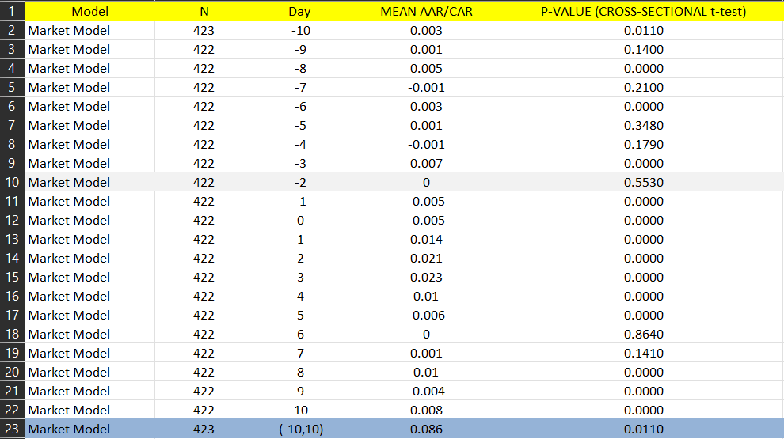
Fig: H1 Test Results

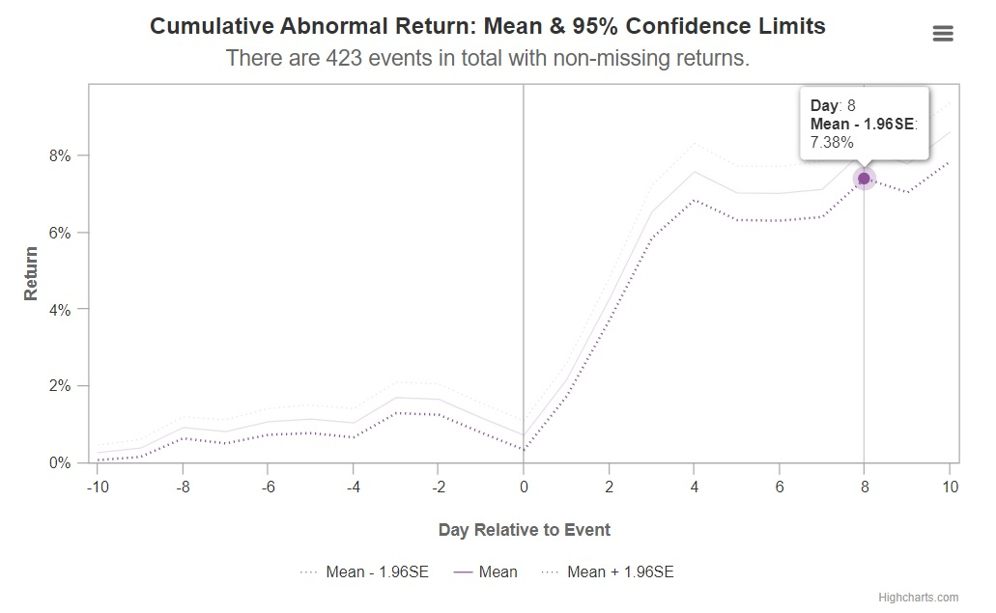
Fig: CAR Mean
However, as the event time progresses closer to the election day, the AAR values become more substantial and statistically significant. For instance, at -8 days, the AAR is 0.005 with a p-value of 0.0000, indicating a positive impact on stock prices. This trend continues in the subsequent days, with AAR values ranging from 0.001 to 0.023 and all p-values being close to or equal to 0.0000. These results suggest a positive and significant impact of the presidential elections on the stock prices of finance companies as the election approached and unfolded.
In conclusion, based on the market model analysis, there is evidence to suggest that the US presidential elections in November 2016 had a positive impact on the stock prices of finance companies listed in the US stock market. The impact becomes more pronounced and statistically significant as the election approaches, indicating that investors reacted positively to the unfolding events. These findings contribute to our understanding of the link between political events and financial markets, highlighting the importance of considering such factors in investment decisions and financial analysis.

Intergroup Comparison:
To successfully test H2 and H3 hypothesis, I conducted intergroup comparison. Comparing various groups or categories in order to find patterns, differences, and similarities between them is known as intergroup comparison (Woods, R.P. 1996).
- Hypothesis 2 (H2)
By comparing groups within a single industry, it has been found that it is possible to determine whether there are significant differences in stock returns between domestic and foreign companies (Hypothesis 2) and between high and low R&D intensity companies (Hypothesis 3), providing insight into the potential effects of the 2016 Presidential Election on these particular groups.
This can be done using IBM SPSS Independent Sample T-Test.
Following steps were involved in running the test:
- Data Collection and Analysis: The relevant and correct data has been collected from WRDS ( Wharton Research and Data Services ).
- Group Selection: There are two groups selected here.
- Domestic companies are described as ‘D’
- Multinational Companies are described as ‘B’
- ‘N’ signifies numrets.
- Mean CAR: CAR means Cumulative Abnormal Result. The Mean CAR represents the average.
- Variable Measurement : Different types of variables are used to analyse the result in IBM SPSS. LPERMNO is the unique identifier with reference to certain companies in the CRSP database.

Intergroup Comparison Test Result of H2
Group | N | Mean CAR | Mena CAR Difference | p-value independent sample test
Domestic Finance Companies | 374 | 9.53% | 8.86% | 0.0002
Multinational Finance Companies | 48 | 0.66% | 8.86% | 0.0002

Analysing the test results:
- Understanding the abnormal stock return:
After analysing Mean CAR result, we can explain that the impact of 2016 Presidential Election was significant on the Domestic companies (D) more than the Multinational companies (B).
- Statistical Significance:
To understand the significance, we must refer to the o-value. Between the 2 p-value’s, we must consider the p-value from the second row because the p-value in the first row is more than 5% (p-value > 0.05) while the p-value in the second row is less than the 0.005 in the second row of the test result (see appendices).
Here, the term variance denotes the square of the standard deviation which can be helpful to understand that there is no significant difference between the statistical values of variance of Domestic and Multinational companies.
Hence after analysing the results, we can conclude that the overall impact is positive and significant. Hence the Hypothesis 2 is supported.

- Hypothesis 3
The main aim of the Hypothesis 3 (H3) is that to analyse how the impact of the 2016 Presidential Election Results declaration is different with Finance companies with high and low Research & Development Intensity (RDI). This can be done using IBM SPSS Independent Sample T-Test.
In hypotheses 3 , I'll explain how finance businesses with low R&D intensity have mean CARs that are less than those with high R&D intensity, and that the difference between the two is significant because the p-value is less than 0.05. It implies that Finance enterprises with higher R&D intensity than those with lower intensity are more positively and significantly impacted by the 2016 Presidential Election.
Following steps were involved in running the test:
- Data Collection and Analysis: The relevant and correct data for the XRD and SALE variables can be obtained from CRSP/ Compustat Merged Database.
- Group Selection: There are two groups selected here.
- XRD = Research and Development Expense
- SALE = Denotes net sale/turnover.
- ‘N’ signifies numrets.
- Mean CAR: CAR means Cumulative Abnormal Result. The Mean CAR represents the average.
- Variable Measurement : Different types of variables are used to analyse the result in IBM SPSS. LPERMNO is the unique identifier with reference to certain companies in the CRSP database.

Intergroup Comparison Test Result Of H3
Group | N | Mean CAR | Mena CAR Difference | p-value independent sample test
Manufacturing Companies with High R&D Intensity | 175 | 6.56% | 3.63% | 0.0005
Manufacturing Companies with Low R&D Intensity | 205 | 10.19% | 3.63% | 0.0005

Intergroup Test Result
Here, the p-value is 0.000005. The Median is 0.26. But the Mean CAR for the companies with the high R&D Intensity is 6.69% and that of the companies with low R&D Intensity is 10.19%.
Hence we can conclude that the test results are not similar to the H3 and hence the H3 is rejected.

DISCUSSIOIN
The results of the intergroup comparison test show that the 2016 presidential election had a positive effect on finance company stock returns. The impact was shown to be more detrimental for finance organisations with significant R&D intensity, nevertheless. The election also had a comparable effect on domestic and international industrial firms.
The test results for the impact of the 2016 presidential election on finance companies and the difference between domestic and multinational manufacturing companies, as well as low and high R&D intensity companies, align with the proposed hypotheses H1 and H2.
There are inconsistencies in the H3 due to the following reason:
- Other Market Elements
- Consumer Expectations
- Company-Specific Considerations
- Data Limitations for Timing and Duration

My test findings may be useful in the future for the following purposes:
1. Investing Choices
2. Risk Evaluation
3. Analysis of Policy
4. Development of a Strategy
5. Additional Analysis
Stakeholders can learn important information about how the 2016 presidential election affected businesses in the finance and industrial industries by taking into account the findings of the intergroup comparison.
Also, there might be some limitations to the data analysis like data quality, time variations, size of the data, etc.
Above findings confirm that the election had an overall positive impact on finance companies and that domestic and multinational manufacturing companies experienced similar effects.’

Appendices:
- Hypothesis 2:
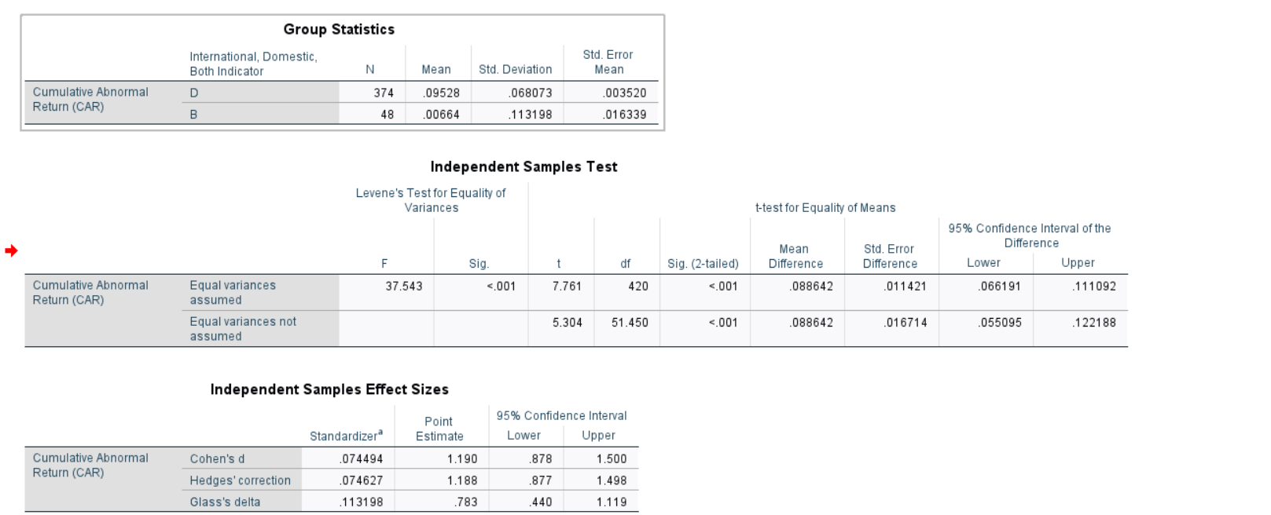
- Hypothesis 3:
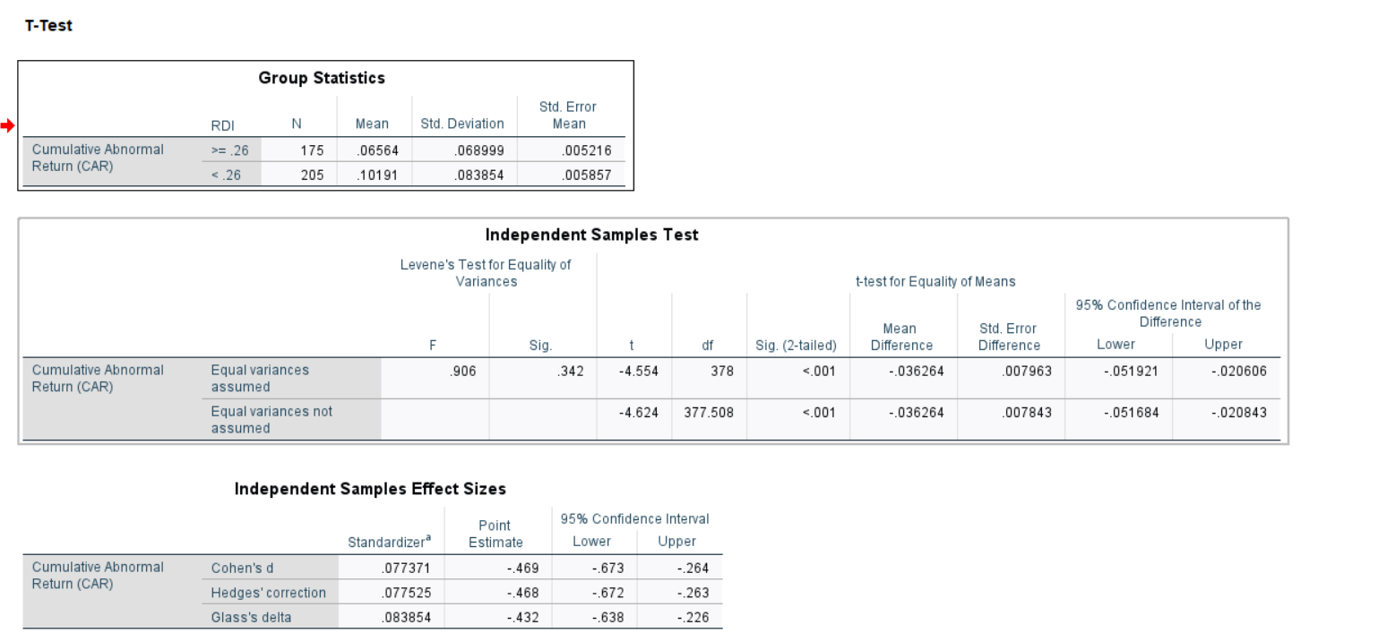

References:
- ‌ Białkowski, J., Gottschalk, K. and Wisniewski, T.P. (2008). Stock market volatility around national elections. Journal of Banking & Finance, [online] 32(9), pp.1941–1953. doi:https://doi.org/10.1016/j.jbankfin.2007.12.021.
- ‌ Moiseev, N.A. (2017). p-Value adjustment to control type I errors in linear regression models. Journal of Statistical Computation and Simulation, 87(9), pp.1701–1711. doi:https://doi.org/10.1080/00949655.2017.1281278.
- ‌ Pennycook, G. and Rand, D.G. (2018). Cognitive Reflection and the 2016 U.S. Presidential Election. Personality and Social Psychology Bulletin, [online] 45(2), pp.224–239. doi:https://doi.org/10.1177/0146167218783192.
- Crandall, C.S., Miller, J.M. and White, M.H. (2018). Changing Norms Following the 2016 U.S. Presidential Election. Social Psychological and Personality Science, 9(2), pp.186–192. doi:https://doi.org/10.1177/1948550617750735.
- Duan, J., Zhang, Y., Ding, X., Chang, C.-Y. and Liu, T. (2018). Learning Target-Specific Representations of Financial News Documents For Cumulative Abnormal Return Prediction. [online] ACLWeb. Available at: https://aclanthology.org/C18-1239 [Accessed 18 May 2023].
- Fertuck, L. (1975). A Test of Industry Indices Based on Sic Codes. The Journal of Financial and Quantitative Analysis, 10(5), p.837. doi:https://doi.org/10.2307/2330275.
- Field, A.P. (2018). Discovering statistics using IBM SPSS statistics. 5th ed. London ; Thousand Oaks, California: Sage Publications.
- Hashim, N. and Mosallamy, D. (2020). Presidential Elections and Stock Market: A Comparative Study. Journal of Finance and Economics, [online] 8(3), pp.116–126. doi:https://doi.org/10.12691/jfe-8-3-4.
- Shaikh, I. (2017). The 2016 U.S. presidential election and the Stock, FX and VIX markets. The North American Journal of Economics and Finance, 42, pp.546–563. doi:https://doi.org/10.1016/j.najef.2017.08.014.
- Woods, R.P. (1996). Modeling for Intergroup Comparisons of Imaging Data. NeuroImage, 4(3), pp.S84–S94. doi:https://doi.org/10.1006/nimg.1996.0058.

